Immutable vs Mutable Strings
# Source: AI Source: Provided by: [Data Path: Persons Table -> ID Column: 1, Name_En Column: Motasem Essam] -> From: [Chatgpt (GPT‑5 Mini)] on [1/26/2026]
Strings in programming can either be immutable or mutable, depending on whether their contents can be changed after creation.

1. Immutable Strings
# Source: AI Source: Provided by: [Data Path: Persons Table -> ID Column: 1, Name_En Column: Motasem Essam] -> From: [Chatgpt (GPT‑5 Mini)] on [1/26/2026]
Definition:
An immutable string is a string whose value cannot be changed once it is created.
Key Points:
- Any operation that modifies the string creates a new string.
- Common in languages like Python, Java, C#.
Example in Python:
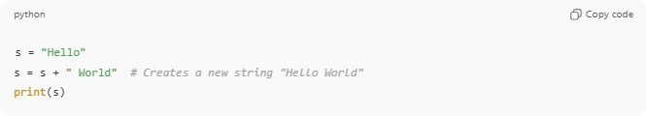
s = "Hello"
s = s + " World" # Creates a new string "Hello World"
print(s)
- Original "Hello" is not modified; a new string is created.
Advantages:
- Safer (cannot accidentally modify strings)
- Thread-safe in multi-threaded programs

2. Mutable Strings
# Source: AI Source: Provided by: [Data Path: Persons Table -> ID Column: 1, Name_En Column: Motasem Essam] -> From: [Chatgpt (GPT‑5 Mini)] on [1/26/2026]
Definition:
A mutable string is a string whose contents can be changed directly after creation.
Key Points:
- You can modify characters in place.
- Common in languages like C (char arrays), C++ (std::string), Java (StringBuilder).
Example in C:
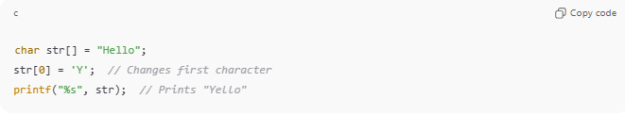
char str[] = "Hello";
str[0] = 'Y'; // Changes first character
printf("%s", str); // Prints "Yello"
Example in Java (StringBuilder):
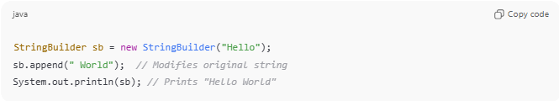
StringBuilder sb = new StringBuilder("Hello");
sb.append(" World"); // Modifies original string
System.out.println(sb); // Prints "Hello World"
Advantages:
- More memory-efficient for frequent modifications
- Faster for operations like concatenation or replacement

Comparison Table
# Source: AI Source: Provided by: [Data Path: Persons Table -> ID Column: 1, Name_En Column: Motasem Essam] -> From: [Chatgpt (GPT‑5 Mini)] on [1/26/2026]
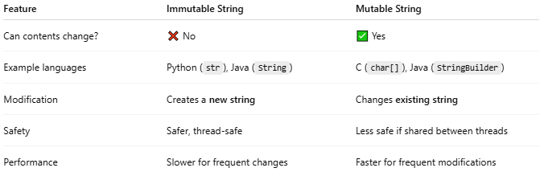
Feature | Immutable String | Mutable String
Can contents change? | ❌ No | ✅ Yes
Example languages | Python (str), Java (String) | C (char[]), Java (StringBuilder)
Modification | Creates a new string | Changes existing string
Safety | Safer, thread-safe | Less safe if shared between threads
Performance | Slower for frequent changes | Faster for frequent modifications

Analogy
- Immutable string → Carved stone tablet (cannot change, only make a new one)
- Mutable string → Whiteboard (can erase and rewrite easily)

If you want, I can draw a simple diagram showing immutable vs mutable strings in memory, which makes this concept super easy to visualize.
Do you want me to make that diagram?

